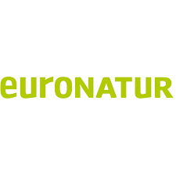
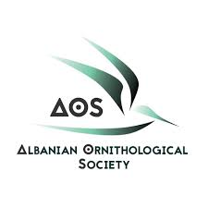
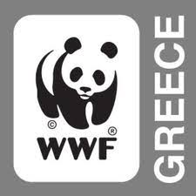
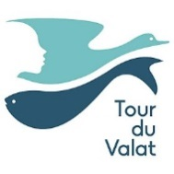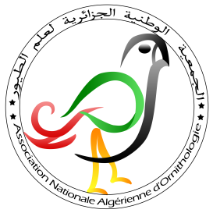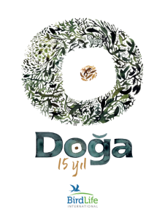
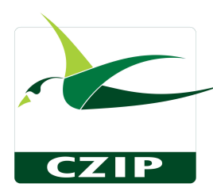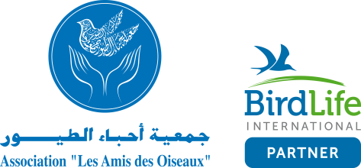
October 8, 2020
To:
Prime Minister of the Hellenic Republic
Mr Kyriakos Mitsotakis

8, Efroniou str., Athens 106 34

Subject: Urgent action needed to protect the wetlands of the Erimitis peninsula
Dear Excellency, Mr Prime Minister,
We are writing to express our serious concern about the construction of a tourist resort in the Erimitis peninsula (the so-called ‘Kassiopi project’). We recommend the project be reconsidered and to implement appropriate conservation measures for the protection of the vulnerable coastal wetland ecosystems of this unique area.
The Mediterranean Alliance for Wetlands is a network of research organizations and environmental NGOs, whose aim is:
‘to raise collectively the profile of wetlands in the Mediterranean society at large and in particular in national, regional and international policy through the promotion of innovation and the use of evidence-based best practices as catalysts for change.’
To date the members of the Mediterranean Alliance for Wetlands include 27 organizations from 15 Mediterranean countries. Mediterranean coastal wetlands are of crucial importance not only in supporting a unique biodiversity, and providing protection against climate change effects but also for their cultural values. It is clear that the coastal wetlands of the Erimitis peninsula represent a significant asset for Greece in terms of biodiversity, but also in terms of the provision of numerous ecological services such as protection against natural hazards, erosion protection and water quality regulation to name a few.

The Erimitis peninsula is a largely unspoiled area of northeast Corfu and one of few remaining on the island. Erimitis contains a great diversity of habitats (see Appendix A of this letter) and includes the coastal wetlands protected by the Greek Presidential Decree 229/AAP/2012. These wetlands are important for the conservation of wildlife within other protected areas on the island, but also within the Albanian coast, the closest entry point to continental Europe, where the National Park of Butrint is located (see Appendix B of this letter).

Additionally, as Erimitis is on the Ionian Sea’s corridor for migratory birds, the three wetlands mentioned are a “stopover point” for bird populations on the north of Greece and among some of the most important wetlands of Corfu. A number of birds recorded in Erimitis are classified as threatened and officially under protection by the Birds Directive of the European Union (EU Birds Directive Annex I, see Appendix C of this letter), therefore the EU Member States must adopt special conservation measures and designate Special Protection Areas for their conservation. In addition, numerous other species protected by the EU Habitat directive depend on the existence of these wetlands, like the Eurasian otter (see Appendix B) , the common tree frog, the European pond terrapin, the Balkan terrapin and the dice snake (EU Habitats Directive Annex IV, see Appendix D of this letter). Some of the aforementioned species are also protected by the Bern and Bonn Conventions, of which Greece is a contracting party.

However, the “Kassiopi project” -which includes the construction of a hotel, tens of villas and apartment blocks as well as a marina for boats in the Erimitis peninsula, may have serious adverse effects upon two important coastal wetlands, Vromolimni and Akoli and the habitats and species in the area.

The threats associated with the “Kassiopi project” include increased noise pollution, water pollution, light pollution, alteration of the catchment area and water regime, loss of vegetation and ecosystem fragmentation, ultimately resulting in habitat loss. Such impacts will lead to the degradation of these vulnerable and habitats and species, contrary to Greece’s obligations stemming from international and EU law as presented above. Furthermore, the recent fire, which took place on Erimitis on August 16 this year, destroying 16 hectares of land, demonstrates the fragility of this area and highlights the lack of, but also the need for, an appropriate protective and management regime.

We have been informed that there is currently strong local opposition to the project, from the municipality of North Corfu, the Local Council of Sinies and other stakeholders, including residents and all local environmental organizations, all of whom have issued statements against the ‘Kassiopi project’ and in favor of the preservation of the peninsula. We are also aware that the local community and local authorities have repeatedly expressed their position against this project, by voting and filing lawsuits against it and by advocating for the environmental protection of the whole peninsula. The views of the local community and other stakeholders opposing the project have not been taken into account, despite the important role international and EU law attributes to environmental democracy and public participation to environmental decision-making as crucial elements of sustainable development.

Appropriate measures need to be taken for the designation of this area as a protected area in line with Directives 92/43/EEC and 2009/147/EC, and national Law 1650/1986 (as amended). Conservation measures need to be adopted for the protection of the specific habitats and species in line with the Bonn and Bern Convention and the EU nature Directives. Furthermore, the presidential decree 229/AAP/2012 on small island wetlands should be effectively applied and appropriate measures should be taken for the protection of these wetlands. Given the vulnerability of these ecosystems and species, only minor activities that would not alter the ecological properties of the wetland should be allowed within this area, such as hiking and running through the existing paths and of course, nature observation and research.

The Mediterranean Alliance for Wetlands, together with members of the association Erimiti Plous, envisage and propose a different future for this area, in which Erimitis benefits from a strict protection status, which acknowledges its value and the important ecosystem services offered to the people of the surrounding areas including socio-economic and cultural services. With this vision in mind, we ask for the “Kassiopi project” to be reconsidered and for conservation measures to be adopted for the protection and conservation of these unique habitats and species in line with international, EU and national law.

Protecting these wetlands should not be considered as an obstacle to the country’s development, but rather as an opportunity to demonstrate leadership towards sustainable development, holistic development that takes into account local needs and wishes, and adherence to international and EU law. Encouraging environmental protection is crucial for the future integrity of Greece, as well as for the image of the country in the European Union, and abroad. Should this vision be endorsed, we will be ready to contribute to making it possible.
We remain at your disposal to provide further information on our position and to contribute, with our expertise and know-how, to the protection and preservation of the significant coastal wetlands in the Erimitis peninsula.
Sincerely yours,

The member organizations of the Mediterranean Wetlands Alliance, whose logos are on the top of this letter

Cc:

APPENDIX
The following documents have been prepared by Elena Papadopoulou (MSc Landscape Ecology) based on data collected by the biologist Xavier Gremillet, the zoologists Marie Stille and Bo Stille, the ornithologist Giannis Gasteratos and the Flora Ionica working group of the University of Vienna.

Appendix A: Habitat types in Erimitis (Habitats Directive 92/43/EEC Annex I)
- 1120* Posidonia beds (Posidonion oceanicae)
- 1150* Coastal lagoons
- 1170 Reefs
- 1210 Annual vegetation of drift lines
- 1310 Salicornia and other annuals colonizing mud and sand
- 1240 Vegetated sea cliffs of the Mediterranean coasts with endemic Limonium spp.
- 1410 Mediterranean salt meadows (Juncetalia maritimi)
- 1420 Mediterranean and thermo-Atlantic halophilous scrubs (Sarcocornetea fruticosi)
- 5230* Arborescent matorral with Laurus nobilis
- 5320 Low formations of Euphorbia close to cliffs
- 5330 Thermo-Mediterranean and pre-desert scrub
- 9310 Aegean Quercus brachyphylla woods
- 9340 Quercus ilex and Quercus rotundifolia forests
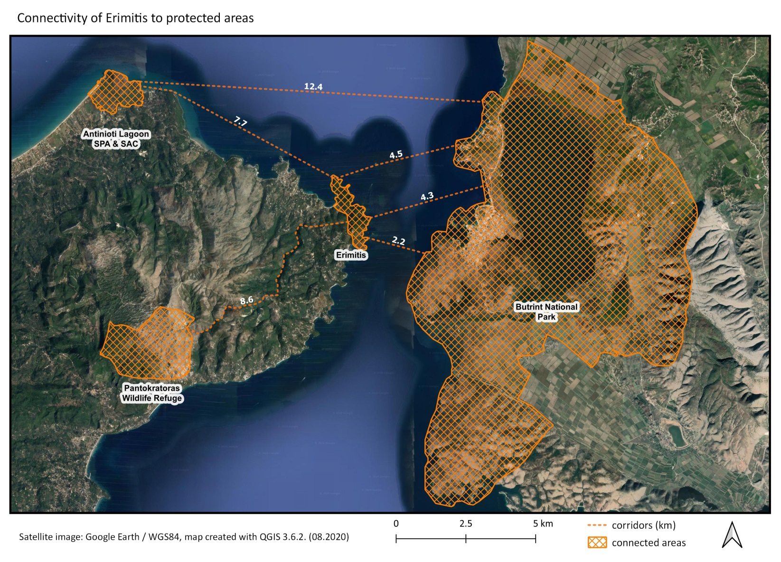
Appendix B: Connectivity of Erimitis to protected areas

Appendix C: List of strictly protected wetland bird species in Erimitis

Scientific Name | English Name | Directive 2009/147/EC Annex I | Bern Convention Annex II | Bonn Convention Annex II
Aythya nyroca | Ferruginous duck | + |  | +
Podiceps nigricollis | Black-necked grebe |  | +
Phalacrocorax aristotelis | European shag | + | +
Ixobrychus minutus | Little bittern | + | + | +
Ardeola ralloides | Squacco heron | + | +
Egretta garzetta | Little egret | + | +
Ardea alba | Great egret | + | + | +
Ardea purpurea | Purple heron | + | + | +
Plegadis falcinellus | Glossy ibis | + | + | +
Tringa glareola | Wood sandpiper | + | + | +
Sterna sandvicensis | Sandwich tern | + | + | +
Alcedo atthis | Common kingfisher | + | +
Motacilla flava | Yellow wagtail |  | + | +
Motacilla cinerea | Grey wagtail |  | + | +
Motacilla alba | White wagtail |  | + | +
Cettia cetti | Cetti’s warbler |  | + | +
Acrocephalus scirpaceus | European reed warbler |  | + | +
Acrocephalus arundinaceus | Great reed warbler |  | + | +
Hippolais pallida | Eastern olivaceous warbler |  | + | +
Appendix D: List of strictly protected Erimitis wetland species (except for birds)
Scientific Name | English Name | Directive 92/43/EEC |  | Bern Convention Annex II | Greek Presidential Decree  67/81
 |  | Annex II | Annex IV
Lutra lutra | Eurasian otter | + | + | + | +
Hyla arborea | Common tree frog |  | + | + | +
Bufo bufo | Common toad |  |  |  | +
Lissotriton vulgaris graecus | Greek smooth newt |  |  |  | +
Emys orbicularis | European pond terrapin | + | + | + | +
Mauremys rivulata | Balkan terrapin | + | + | + | +
Natrix tessellata | Dice snake |  | + | + | +
Natrix natrix | Grass snake |  |  |  | +

List of references

Literature
- Gasteratos, Ι. 2020: Changes at the ecosystems of Corfu – Some examples, Scientific-Educational Conference “Biodiversity – Climate Change & Impacts on island ecosystems”, organized by Management body of protected ares of Corfu, Kalamas, Acheron, held in Corfu, Greece on 6th-8th March 2020.
- Gremillet X. (1998): Otter (Lutra lutra) Surveys on Corfu island and at lakes Prespa (Greece), Proc. VIIth International Otter Colloquium.
- Gremillet X. (1993): Field survey of Lutra lutra on Corfu island (Greece). IUCN Otter Spec. Group Bull. 8: 39-42.
- Stille Bo & Marie Stille (2017): The Herpetofauna of Corfu and Adjacent Islands. Edition Chimaira, Frankfurt am Main.

Legislation
- Bern Convention: “Convention on the Conservation of European Wildlife and Natural Habitats“, adopted on 19 September 1979 in Bern, Council of Europe, Official Journal L 38 of 10.02.1982.
Amended by the Standing Committee on 8th March 2018.
- Bonn Convention: “Convention on the conservation of migratory species of wild animals”, signed in 1979 in Bonn, Official Journal L 210 of 19.07.1982. Amended by the Conference of the Parties in 22 May 2020.
- EU Birds Directive: “Directive 2009/147/EC of the European Parliament and of the Council of 30 November 2009 on the conservation of wild birds“, European Parliament and European Council, Official Journal L 20 of 26.01.2010. Codified version of Directive 79/409/EEC. Transposed into Greek legislation through the Joint Ministerial Decision 414985/29-11-85(G.G. Β΄757), the Joint Ministerial Decision 37338/1807/E.103/1-9-10 (G.G. 1495/B/6-9-10) and the Joint Ministerial Decision 8353/276/Ε103/17-2-2012 (G.G. 415/Β/23-2-2012).
- EU Habitats Directive: “Council Directive 92/43/EEC of 21 May 1992 on the conservation of natural habitats and of wild fauna and flora“, European Council, Official Journal L 206 of 22.07.1992. Transposed into Greek legislation through the Joint Ministerial Decision 33318/3028/11-12-1998 (G.G. 1289/Β/28-12-98) and the Joint Ministerial Decision 14849/853/Ε103/4-4-2008 (G.G. 645/Β/11-4-08).
- Presidential Decree for the protection of small island wetlands: "Approval of a list of small island wetlands, and provision of terms and conditions for the protection and conservation of small coastal wetlands included therein" (G.G. AAP 229/19-06-2012).
- Presidential Decree No 67/81:”Greek presidential decree on the protection of native flora and wild fauna and the determination of the coordination and control procedure of related research” (G.G. 23/A/30-01-1981).

Namely lake Antinioti, Korission Lagoon and Alykes of Lefkimmi.
From 2011 to 2019 all regional and local authorities have expressed their opposition to the plan, by voting on statements about the development.

